Good day,

Please find the responses to the queries raised. These were uploaded on 16 Febr:

Q1 - Open source(University of Amsterdam), Amsterdam, Netherlands
Q2 - Barua – 1 to 44
Q3 – Cambridge
Q4
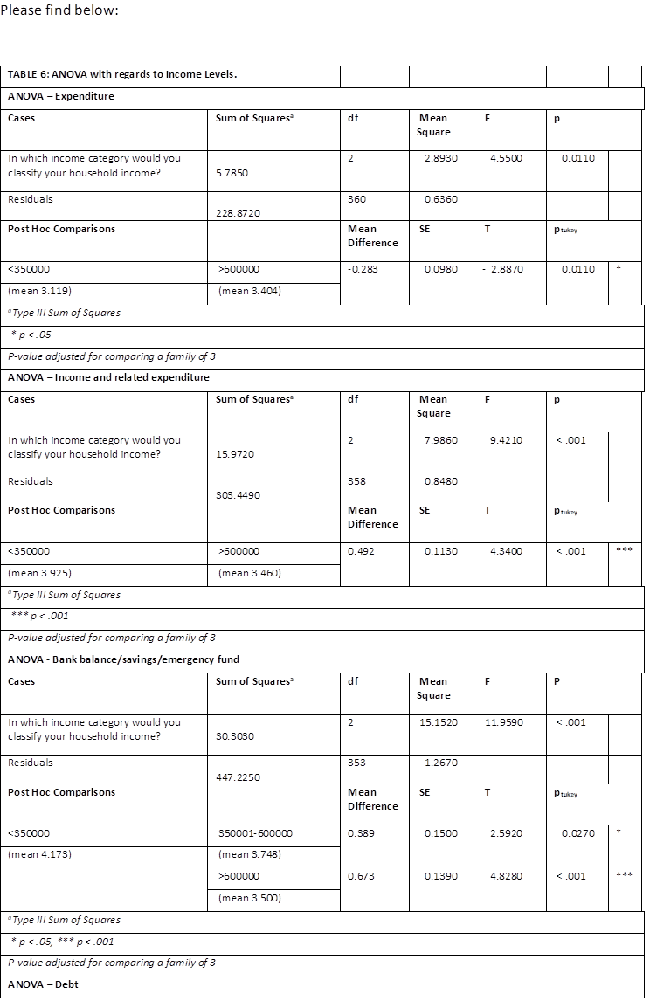

Q5 - Checked

Please confirm receipt.

Regards
Jaco

